Name: rehab helal

**(1) Power Budget**

|  |  |  |  |  |  |  |  |
| --- | --- | --- | --- | --- | --- | --- | --- |
| Components | Quantity | Voltage (V) | Current (mA) | Duty Cycles | Power (W) | Energy (Wh) | Source |
| Arduino UNO | 1 | 9 | 40 | 3:00:00 | 0.36 | 1.08 | datasheet |
| DHT11 | 1 | 5 | 2.5 | 3:00:00 | 0.0125 | 0.0375 | datasheet |
| MPU6050 | 1 | 3.3 | 3.9 | 3:00:00 | 0.01287 | 0.03861 | datasheet |
| BMP180 | 1 | 3.3 | 1 | 3:00:00 | 0.0033 | 0.0099 | datasheet |
| Ublox GPSNEO6_M | 1 | 3.3 | 10 | 3:00:00 | 0.033 | 0.099 | datasheet |
| NRF24L01 RF | 1 | 3.3 | 12 | 3:00:00 | 0.0396 | 0.1188 | datasheet |
| SD Module | 1 | 5 | 200 | 3:00:00 | 1 | 3 | datasheet |
| Servo motor | 1 | 5 | 360 | 0:00:30 | 1.8 | 0.015 | datasheet |
| Camera | 1 | 5 | 0.025 | 3:00:00 | 0.000125 | 0.000375 | datasheet |
| Buzzer | 1 | 5 | 30 | 0:00:10 | 0.15 | 0.0004166666667 | datasheet |
| buzzer | 1 | 5 | 10 | 0:00:30 | 0.05 | 0.0004166666667 | datasheet |
| led | 6 | 2 | 100 | 3:00:00 | 0.2 | 3.6 | Estmited |

|  |  |
| --- | --- |
| Total Energy Consumption (Wh) | **8.000018333** |
| Available Energy (Wh) | 13.5 |
| Margin | 5.499981667 |

**(2) Battery Sizing**

Market Survey:

|  |  |  |  |
| --- | --- | --- | --- |
| Model | delipow | Lithium Ion 14500 | li-ion 18650 |
| Battery Type | Rechargeable | Rechargeable | Rechargeable |
| Chemistry | li-ion | li-ion | li-ion |
| Quantity | 2 (Parallel) | 2(Series) | 2(Series) |
| Mass (kg) | Will be measured | 21 g | 48g |
| Voltage (V) | 9 v | 3.7 v | 3.7 v |
| Capacity (mAh) | 800 mAh | 1200 mAh | 1500mAh |
| Maximum Discharge Current (A) | 50mA | 1C | 2.850A |
| Temperature Limits (°C) | 10 – 45 | ----- | -20˚C to 60C |
| Dimensions | AA | Diameter 14.2 mm Height 48.5 mm | diameter of 18mm and is 65mm long |
| Cost | 300 LE | 40 LE | 65LE |
| Link | https://ram-e-shop.com/product/battery9v-rech/ | https://lampatronics.com/product/battery-li-ion-battery-cell-3-7v-1200mah-14500/ | https://ram-e-shop.com/product/lithium-rechargeable-battery-18650-3-7v-blue/ |

Battery Selection:

|  |  |
| --- | --- |
| **Selected Battery** | **Reasons** |
| li-ion 18650 | **(1)cheaper**  **(3)high capacity** |

**(3)solar cell**

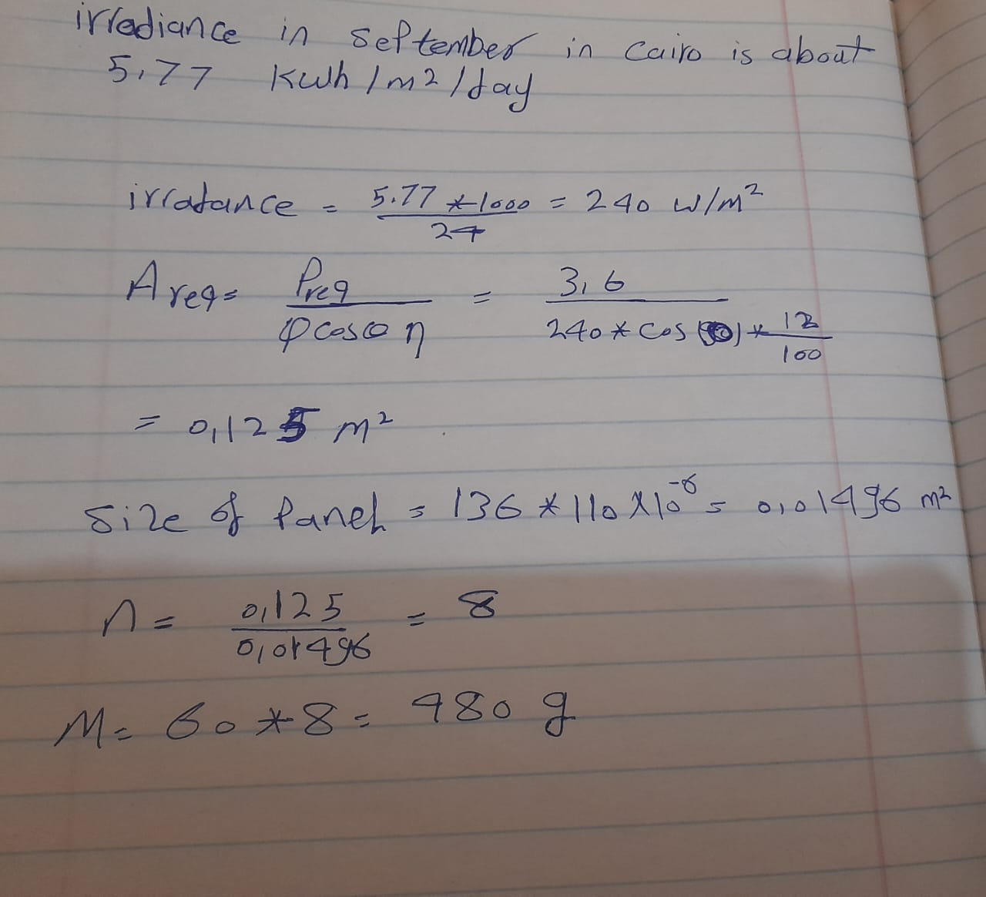

**References:**

**[1]** http://www.solarelectricityhandbook.com/solar-irradiance.htm

**[2]** **https://docs.google.com/spreadsheets/d/1n0hPMGJB6EnIalECckx-uKT_rQ2qZ_fRZIUFvpndmDU/edit#gid=0**